**ECEN 248 - Lab Report**

**Lab Number: 11**

**Lab Title: The Traffic Light Controller Lab**

**Section Number: 519**

**Student’s Name: Alex Allahar**

**Student’s UIN: 9280098686**

**Date: 12/05/2023**

**TA: Yi Deng**

**Objectives:**

The purpose of this lab is to introduce the use of Mealy Machine. Compared to the Moore Machine this FSM design differs in that the current state and current input both affect the output. To view the impact of this FSM design a traffic light controller will be created in Verilog.

**Design:**

To begin this lab design the traffic light controller fsm, in a design source module. This is intended to be done before the lab. Once this fsm module is functional add to a new project called lab11. Create another design source called tlc_controller using the starter code in the lab manual as a starting point. Once this module is completed, add the synchronizer.v and tlc_controller.xdc files from the course directory into the project as a design and constraint source respectively. Synthesize the project, and ensure no errors occur. Once completed, implement the project. Finally, load the program onto the FPGA. Verify that the system is functioning correctly using the LEDs and the highway and farm signals.

For the next part of the lab, a sensor for the farm road signal will be added to the design. To do so modify the fsm module with the specification provided in the lab manual. Once the sensor is added to the design, resynthesis and reimplement the design. Once the new design passes these tests load the program onto the FPGA, and test the sensor using the button to mimic the sensor output.

**Conclusion:**

In this lab I was able to design a Mealy Machine, which shows a FSM that is dependent on the state and input, unlike the Moore Machine. Furthermore, I was able to design a real world application within Verilog.

**Post-lab Deliverables:**

1. **Source Code**

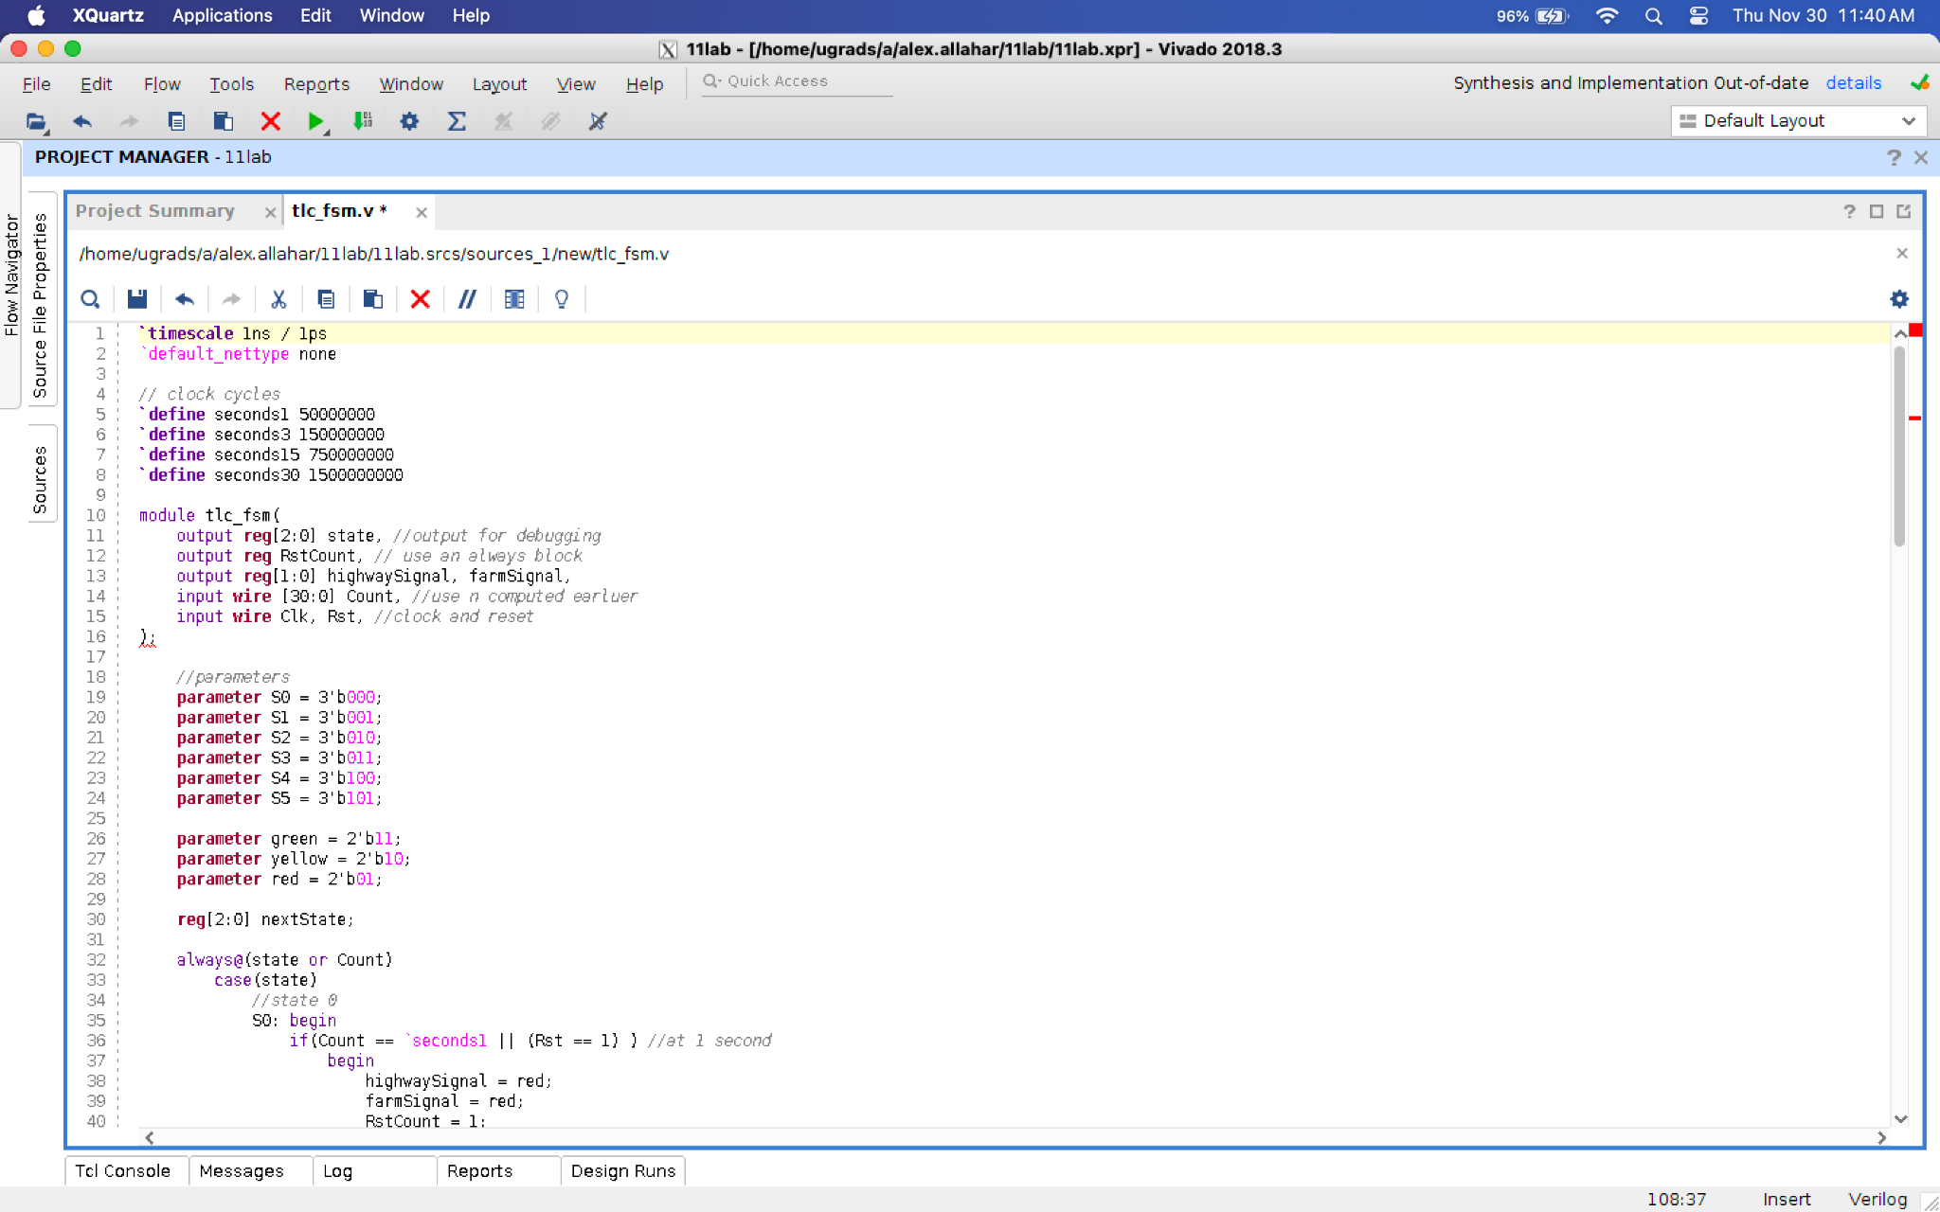

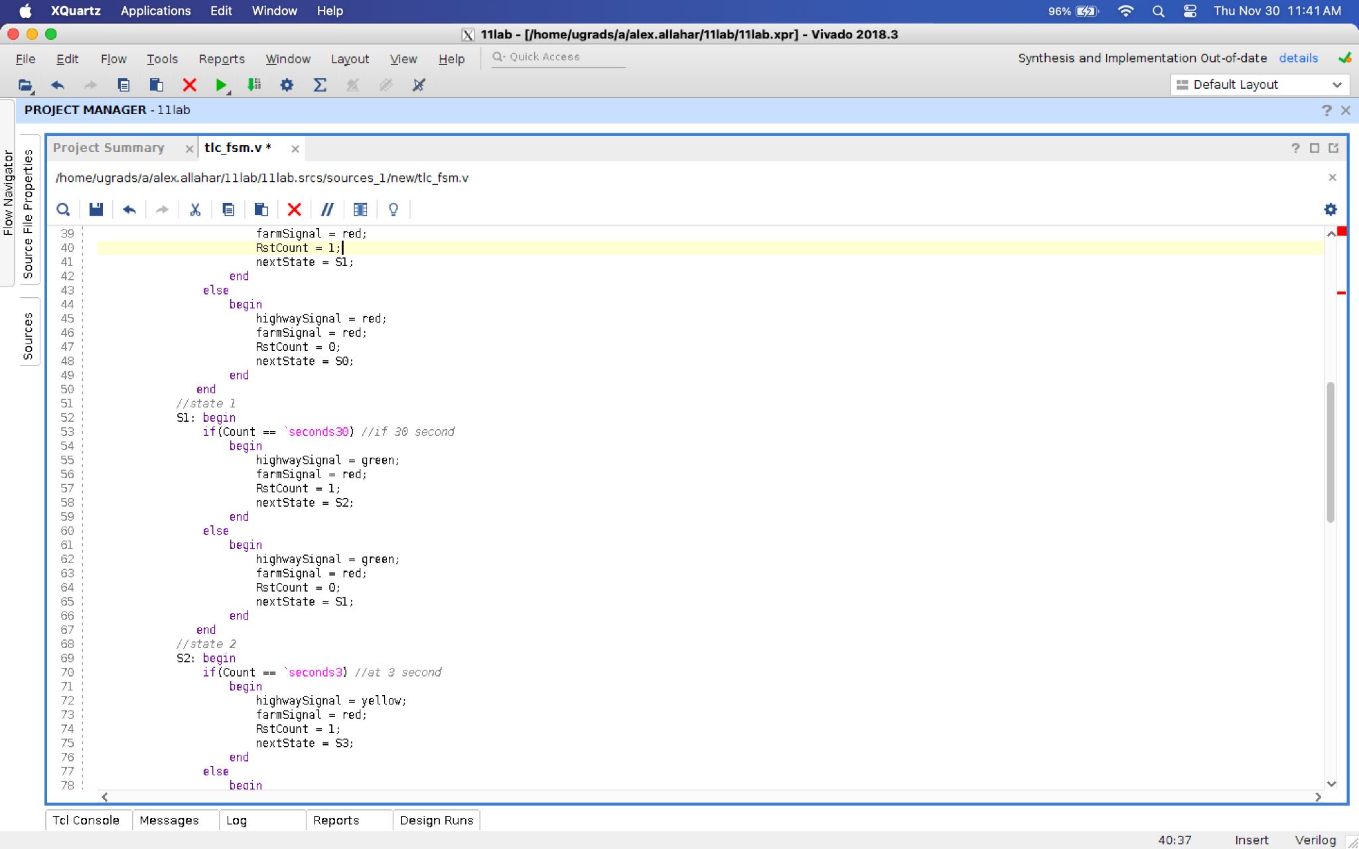

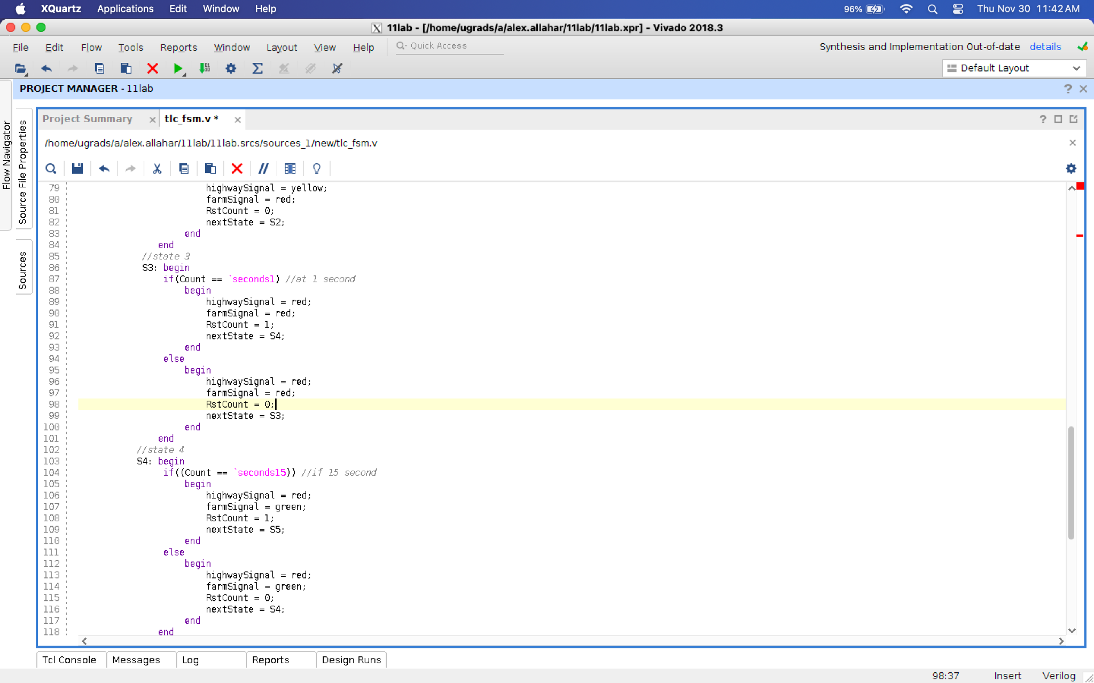

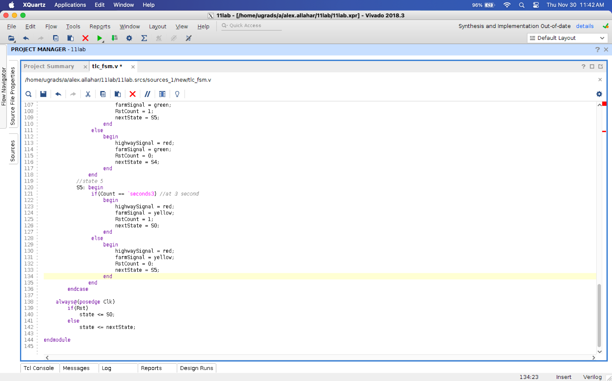

**Figure 1: FSM without FarmSensor Code**

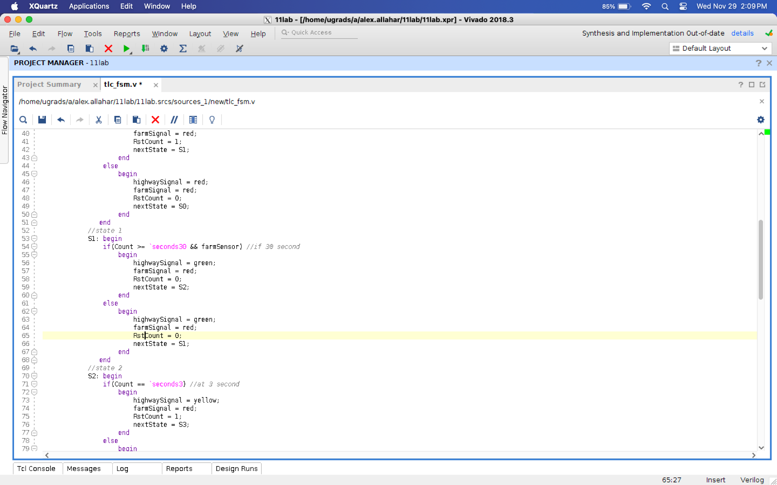

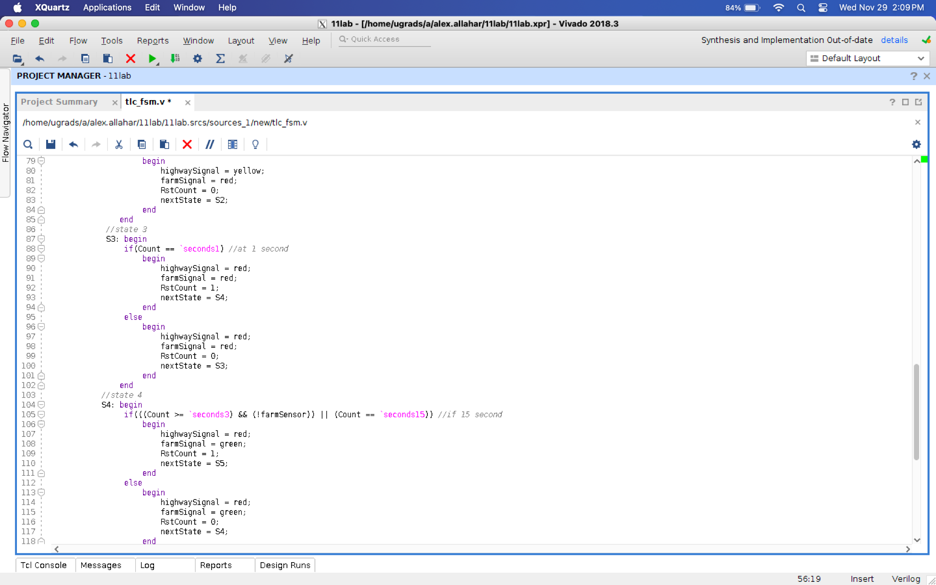

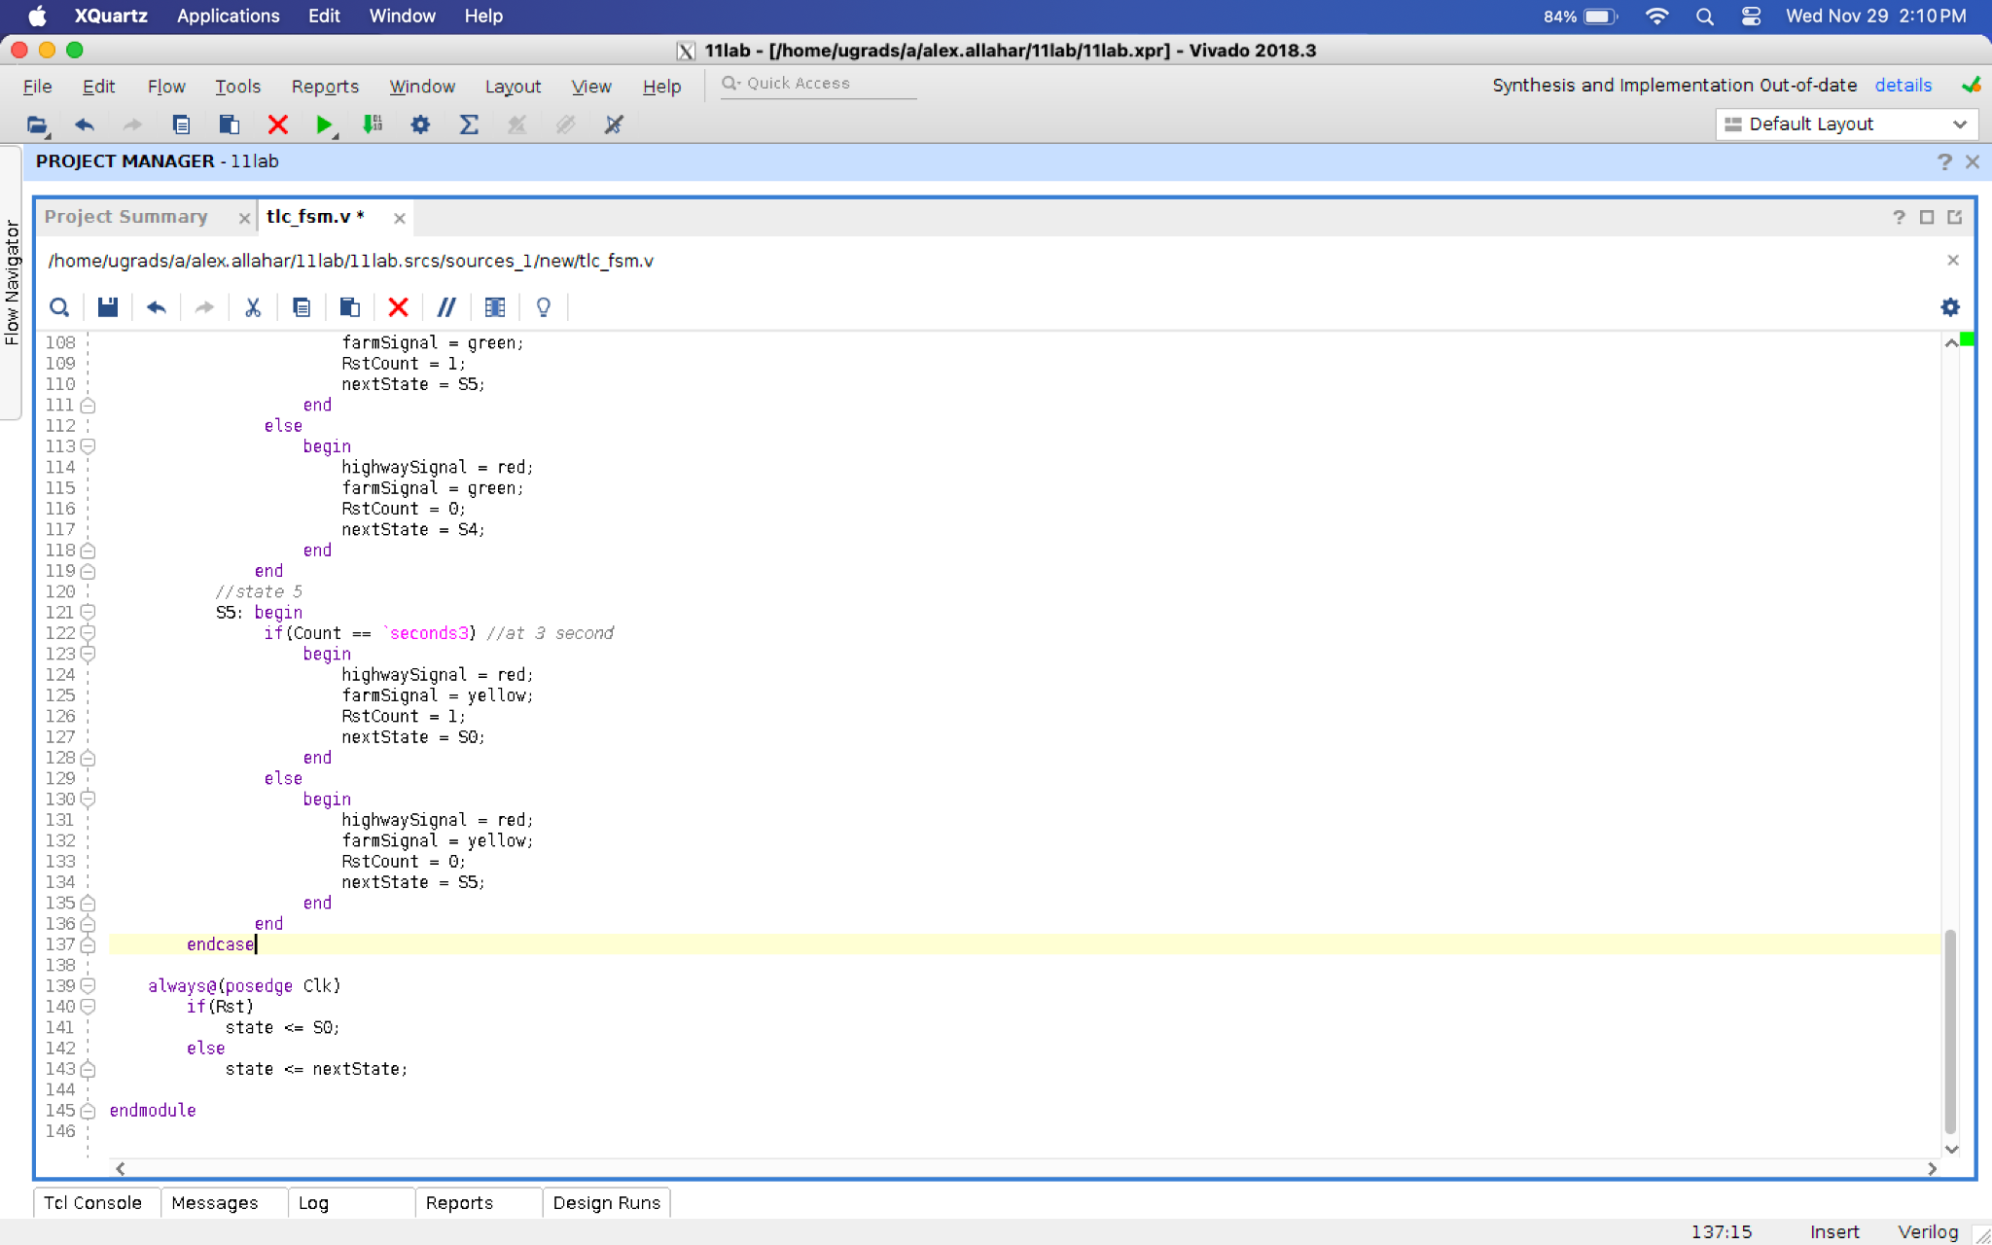

**Figure 2: FSM with FarmSensor Code**

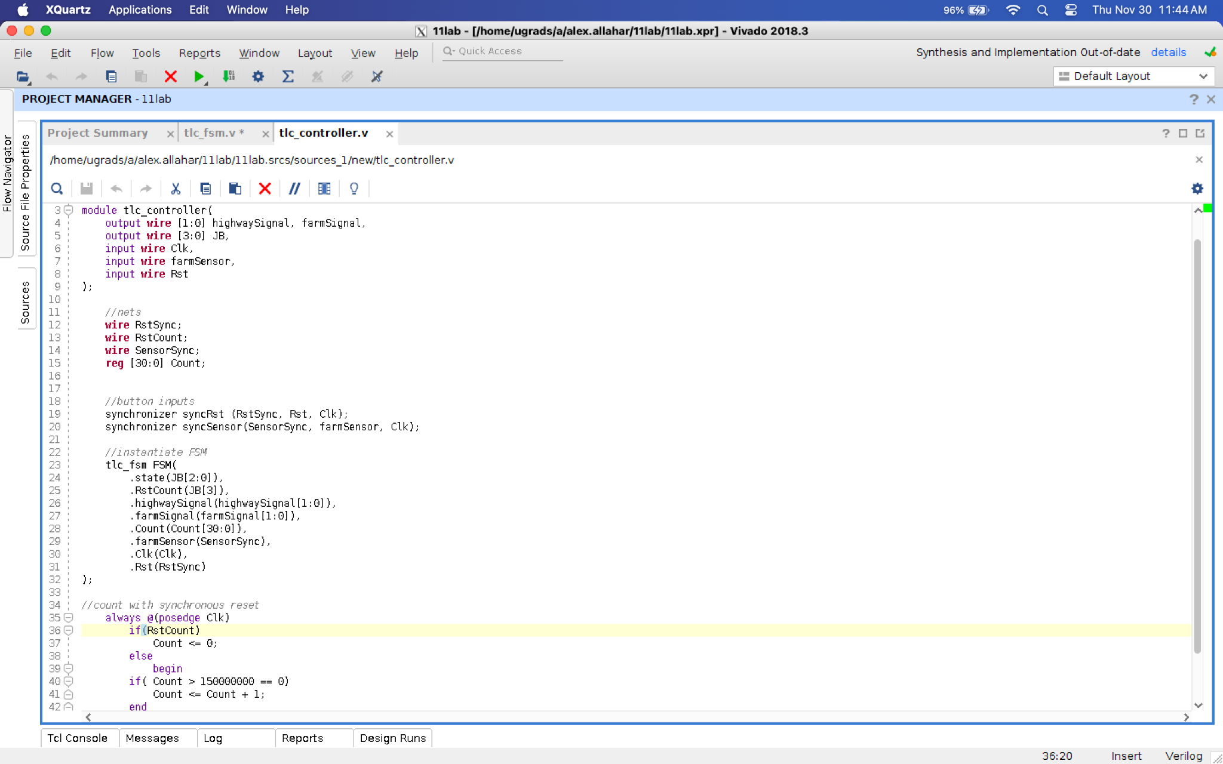

**Figure 3: TLC_Controller Code**

1. **State Diagram of the modified traffic light controller FSM**

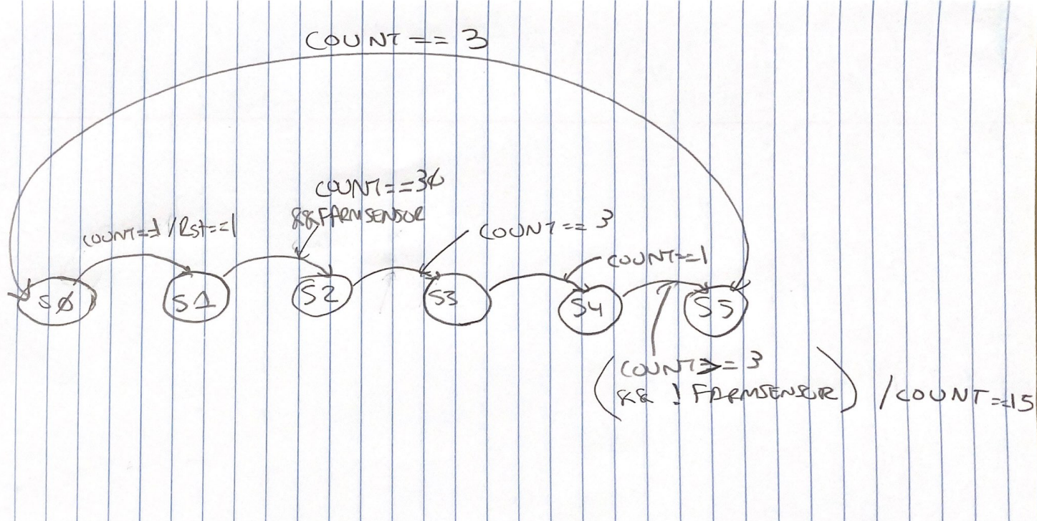

**Figure 4: State Diagram**